**Guava BBQ Fried Wings**

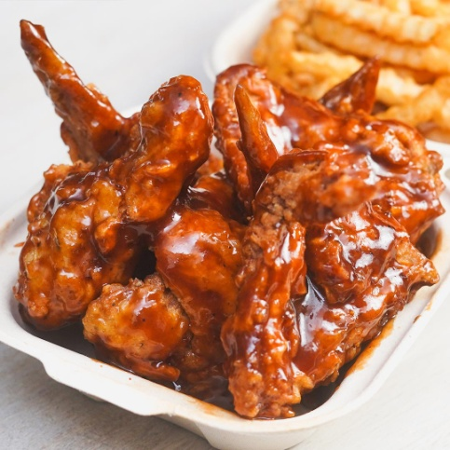

**FRIED WINGS INGREDIENTS**

3 pounds chicken wings separated

2 tablespoons blackening seasoning

2 eggs

1/4 cup milk

2 dashes hot sauce (I have)

2 tablespoon corn starch

2 cups all purpose flour

1 teaspoon seasoning salt

3 cups vegetable oil for frying

SAUCES

Guava BBQ Sauce

Guava Jam

**Guava BBQ Sauce**

Add Jam to BBQ Sauce in a saucepan and simmer for 10 minutes

Garlic Sauce

2 tsp Minced Garlic

1 cup Mayo

1 tsp Sugar

2 Chadon Beni leaves finely chopped

Combine ingredients

**METHOD**

1. Place chicken wings in a bowl and sprinkle blackening seasoning over the top. Toss to coat. Cover and refrigerate for 30 minutes.
2. In a bowl whisk together eggs, milk and hot sauce.
3. In a shallow bowl combine corn starch, flour and seasoning salt.
4. Dip chicken wings into the egg/milk wash and then dredge in the seasoned flour.
5. Heat 2 inches of oil in a heavy duty pan over medium-high heat. Once oil reaches 350 degrees begin frying chicken in batches until golden brown and cooked through, 5 – 7 minutes.
6. Transfer to a paper towel lined plate.
7. Allow to cool slightly.
8. Toss Fried Wings in Guava BBQ Sauce